**Model Menu**

The MOST Model Menu is used for loading and saving of files, as well as clearing the tables and exiting the application.

Note that if any changes have been made or Optimizations have been run previously to performing any load or Clear Tables actions, the “Save Changes” prompt will appear.

Load SBML:

Select Model –> Load SBML (Alt+M then Alt+L) then select a file with an “.xml” or “.sbml” extension that is a valid SBML file. If the file is not valid, a message will appear.

The Progress Bar will appear.

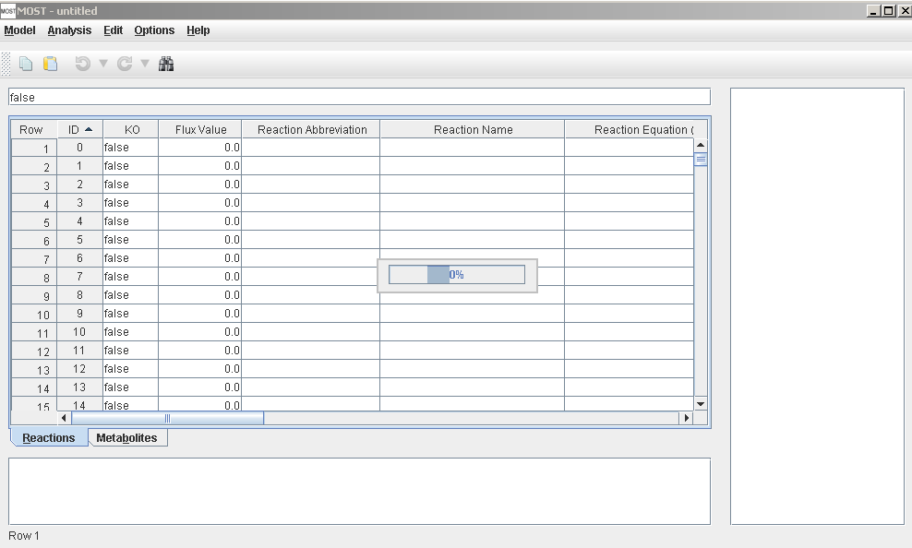

When the file has completed loading, the Progress Bar will close.

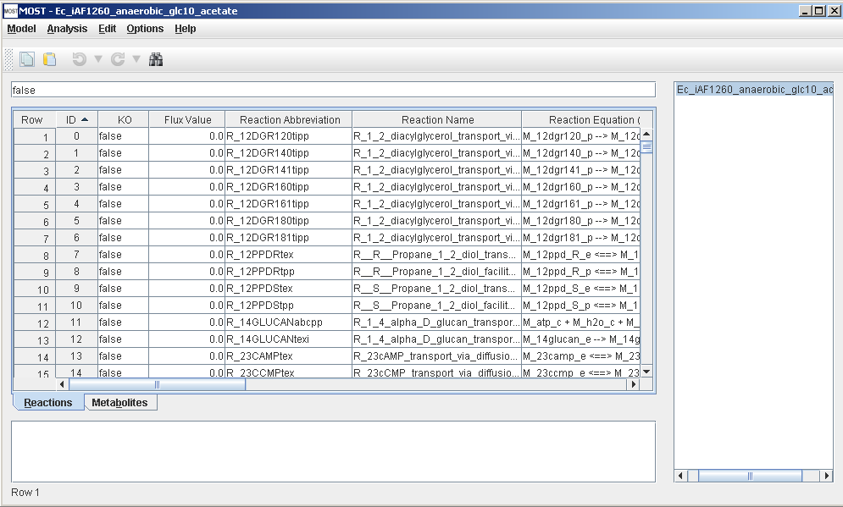

Load CSV:

MOST can load CSV files of reactions, metabolites or reactions and metabolites together. If a reactions file is loaded and a reactant is encountered that is not present in the Metabolites table, MOST will prompt the user to add it. If a reaction file is loaded by itself, the file will generate the metabolites for the Metabolites table. One note: if a reactions CSV file is loaded by itself, all the boundary conditions will be set to “false” by default for the generated Metabolites table.

In order to load Microsoft Excel spreadsheets, save each table as CSV (Comma delimited).

Select Model –> Load CSV (Alt+M then Alt+V)

The CSV File Load Interface will appear.

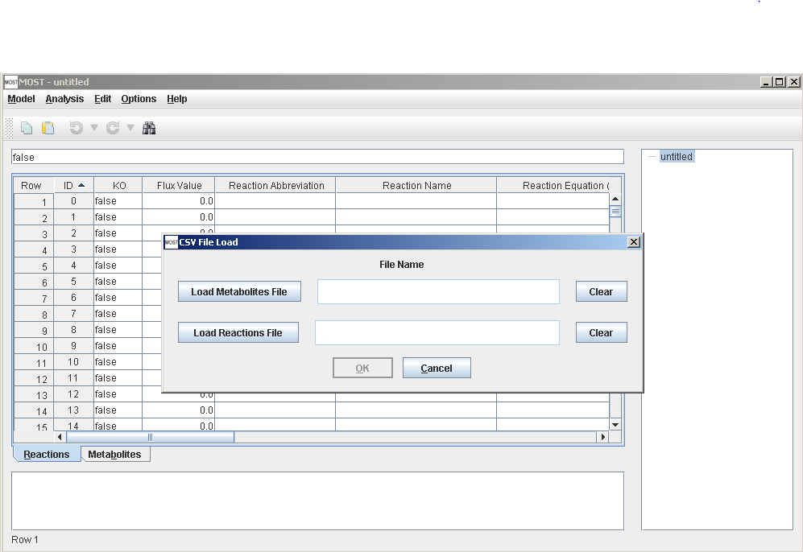

Click the Load Metabolites File button to select a metabolites CSV file and the Load Reactions File button to select a reactions CSV file.

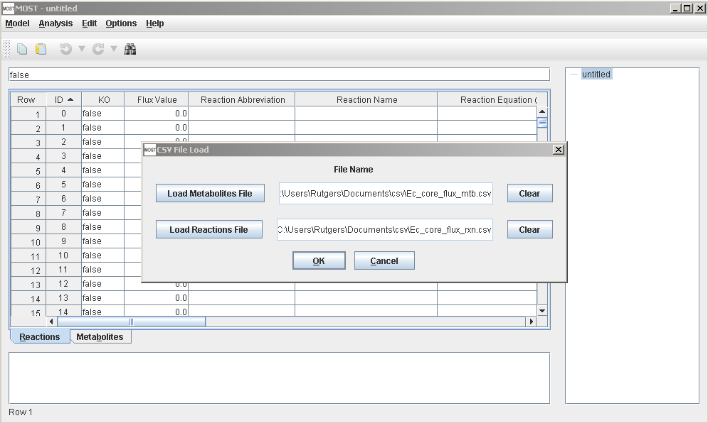

If a metabolites file is selected, the Metabolite Column Selector Interface will appear above the main interface. If the columns selected for core columns are not correct, use the drop boxes to choose the correct column from the file for that column.

If a column is not present in the file, leave the field blank.

If the CSV file has a row before the row with the column names as the example below has “Required”, “Recommended” and “Optional” in the first row, click the “Next Row” button to get to the next row.

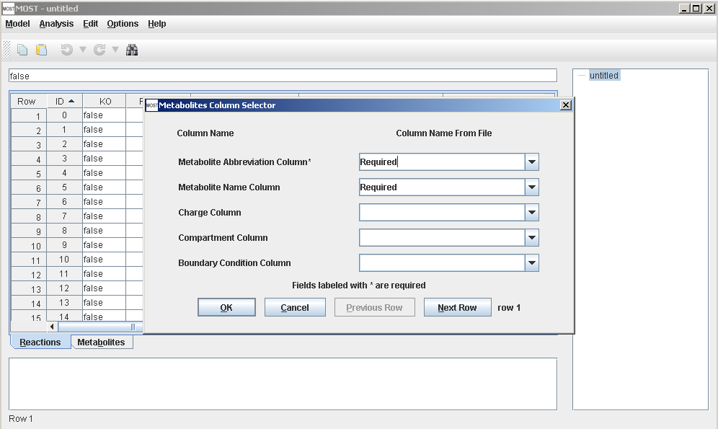

The Metabolite Column Selector should look something like this after columns have been selected. Metabolites Abbreviation is a required field and hence cannot be blank.

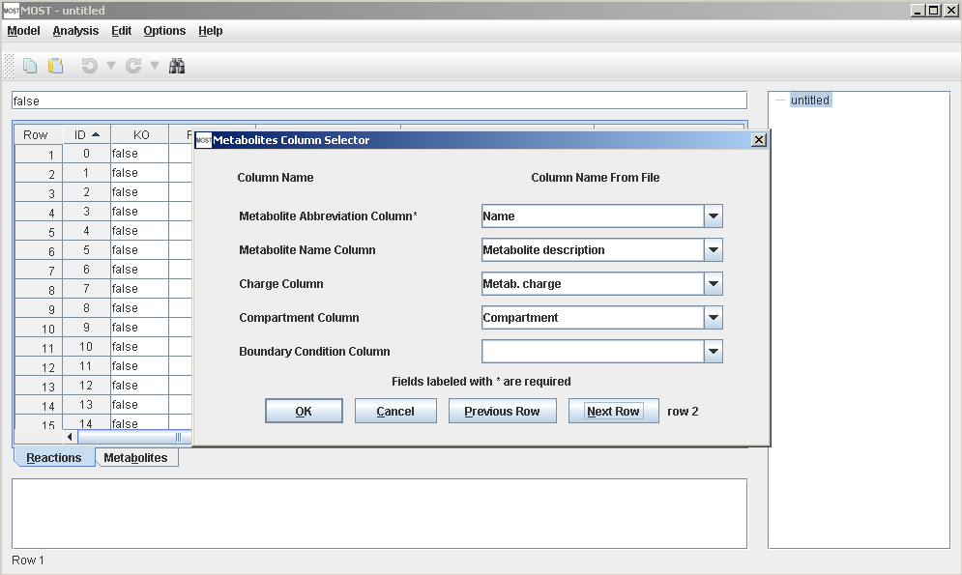

Click “OK”

If a metabolites file was not selected, skip to reactions CSV next.

If a reactions file is selected, the Reaction Column Selector Interface will appear above the main interface. If the columns selected for core columns are not correct, use the drop boxes to choose the correct column from the file for that column. If a column is not present in the file, leave the field blank.

If the CSV file has a row before the row with the column names as the example below has “Required” , “Recommended” and “Optional” in the first row, click the “Next Row” button to get to the next row.

Reaction Abbreviation and Reaction Equation are required fields and hence cannot be blank.

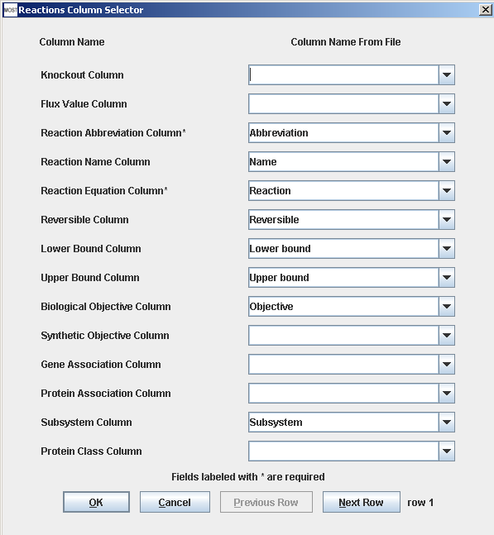

Click “OK”

The file will now load. If there are any reactions that have metabolites/compounds that are not present in the Metabolites table, the Add Metabolite prompt will appear:

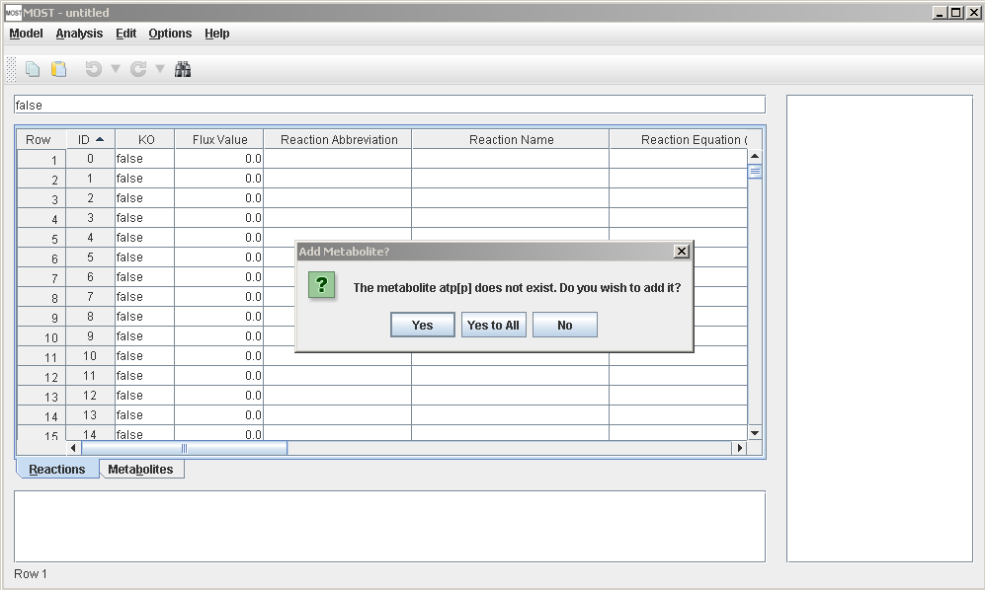

Click “Yes” to add the metabolite, “Yes to All” to suppress the prompt for the rest of the load, or “No” to not add the metabolite. If “No” is pressed, the metabolite will also be removed from the reaction.

Load from Model Collection Database;

MOST has a collection of published models that can be loaded using this menu item.

Select Model –> Load from Model Collection Database (Alt+M then Alt+D)

The Model Collection table will appear.

Select a row on this table that corresponds to the desired model, then click “OK”.

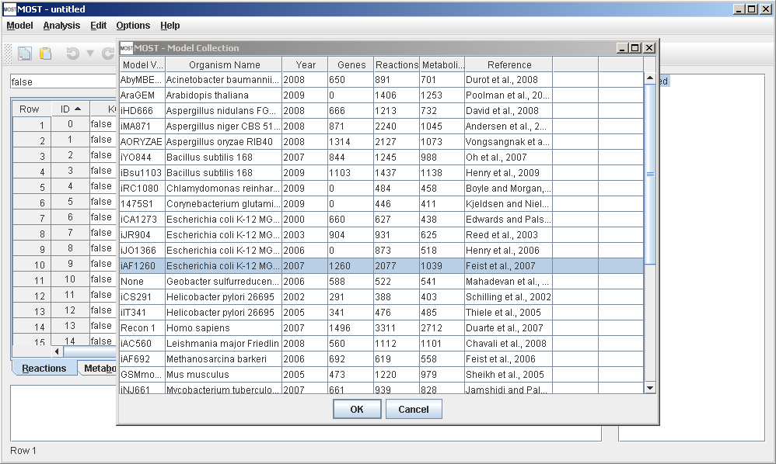

Saving files:

MOST can save files in SBML and CSV file formats. SBML requires that Reaction Abbreviation and Metabolite Abbreviation (Reaction Id and Metabolite Id in SBML files) only contain alphanumeric characters (A-Z, a-z, 0-9) and underscores (_), so when any other character is found in these columns, the character will be replaced with an underscore. Also to conform with the format of many SBML files, if a Reaction Abbreviation does not start with “R_” (or “r_”) or a Metabolite Abbreviation does not start with “M_”, “S_” (or “m_”, “s_”), the appropriate prefix will be added to the abbreviation. The remaining fields cannot contain an ampersand (&). Also, non- ASCII characters are not permitted, and will be replaced with an underscore (_).

Save as CSV does not have these requirements and it will save the file as it appears.

Save

Select Model –> Save (Alt+M then Alt+S or Ctrl+S). Save will automatically save as SBML if the loaded file is SBML, save as CSV Reactions if the loaded file is CSV and the Reactions table is selected or save as CSV Metabolites if the loaded file is CSV and the Metabolites table is selected.

If a model is being built from scratch, the first time Save is executed, the file chooser will be opened in order to name the file to be saved.

Save As SBML:

Select Model –> Save As SBML (Alt+M then Alt+B), and type in the name to use to save the file. The file will be saved with an “.xml” extension. There is also a Save button in the toolbar. If the loaded file is from the Model Collection, the Save menu item and Save button will be grayed out. In order enable the Save menu item and Save button, use Save As SBML to save a copy to another directory such as My Documents.

Save As CSV Metabolites

Select Model –> Save As CSV Metabolites (Alt+M then Alt+O), and type in the name to use to save the file.

Save As CSV Reactions

Select Model –> Save As CSV Reactions (Alt+M then Alt+N), and type in the name to use to save the file.

The files will be saved with a “.csv” extension.

It is recommended that the file names for CSV files consist of the model name followed by a suffix such as “_reactions” or “_rxn” and “_metabolites” or “_mtb”.

If an extension is not typed into the file chooser, it will automatically be added.

Clear Tables:

This function will clear both tables in order to start fresh. Each blank table has 2000 rows.

Select Model –> Clear Tables (Alt+M then Alt+C).

Exit:

Select Model –> Exit (Alt+M then Alt+X) or click the “X” (frame close button) on top right corner.